**White Paper**

**HIP TOKEN**

**I**

**Forward-Looking Statements**

As at the date of issuance of this Treatise, January 19, 2022, Hollywood Int’l Productions, Inc. (Company) and its affiliates have structured and designed the Company’s proposed business enterprises. This Treatise contains statements primarily relating to future results and activities of the Company, including but not limited to financial projections, business trends, software and hardware designs, and systems integrations, that are “forward-looking statements” as defined in the Securities Litigation Reform act of 1995 (the “Litigation Reform Act”). Forward Looking Statements made in this Memorandum are made pursuant to and in reliance upon the safe harbor provisions of the Securities Reform Act of 1995. Section 27A(b)(2)(D) of the Securities Act, and Section 21E(b)(2)(D) of the Securities Exchange Act of 1934, as amended (the “Exchange Act”). Such statements involve risks and uncertainties which will, in all likelihood, cause results to differ materially from those set forth herein.

**II**

**SUMMARY**

**Hollywood Int’l Productions, Inc. (the Company)T is the issuer of the HIP Utility Token. The HIP Utility Token (Token) is a unique collateralized utility token that is native to the Company’s digital streaming platform and earned through a customer rebate and rewards program.**

**The Business of the Company is (a) the production and distribution in all markets worldwide of motion pictures and other entertainment products and (b) the creation and operation of an OTT network that uses the connectivity of the world wide web, the Internet, to disseminate and distribute information and products to the public. The Company is funded by other resources and is channels. not seeking to raise funds through its crypto offering.**

**The Company is seeking to reward participants, subscribers, and viewers of ite OTT platform by distributing HIP Tokens to them based on their usage of the OTT platform and other Company offerings. It is the strong conviction of the Company that the rewards system will encourage sales and revenues for the platform as well as provide revenues for the viewers.**

**The collateral supporting the valuation of the HIP Token (Token) is (a) advertising revenue based on viewership of ad supported content on its OTT streaming platform and (b) gemstones invested in the Company valued at 50Million USD.**

**The Company eco-system (HIP Eco-System or Eco-System) consists of two primary elements:**

**1. Motion picture and entertainment production and distribution throughout the world in all media.**

**2. Digital Streaming Platform integrating content with social media capabilities delivered to the end user via the world wide web (Internet).**

**Among other characteristics of the Token are the following:**

**1. Tokens, although authorized and collateralized, cannot be issued until and unless earned by users of the Hip Eco-System.**

**2. Tokens have an inherent value of $0.10 in fiat (USD) currency or, initially, the same value in ruby gemstones apportioned among the Company’s tokens. The Company will maintain accounts containing the aggregate Token value. The Company will redeem all Tokens for the inherent value. To the extent that there is a basic fiat value for the Tokens, backed by fiat accounts maintained by the Company, the Tokens are “fiat backed crypto currency” To the extent that the Tokens are backed by the value of gemstones, the Tokens are “collateralized.”**

**3. The Company will arrange for the Tokens to be listed on a number of crypto exchanges to facilitate usage and movement.**

**4. Block chain technology and smart contracts will govern the distribution, exchange and redemption of the Tokens, using software designed by the Company integrated with an existing block chain.**

**The Blending of an Asset Back Utility Coin & A fiat Back Rewards Program,**

**The Company is issuing a crypto utility token, denominated as the  Token. The purpose for the issuance is to provide a reward in the form of additional income to viewers and subscribers of the Platform, and to increase the number of user of the OTT and incentivize their usage of the OTT’s offerings. The Token is a “Rewards and Rebate” program that issues  Tokens to viewers based on their viewing habits.  Tokens are redeemable for fiat at the request of the holder of the token. To facilitate using  Tokens beyond the  eco-system, the Tokens will be listed on multiple exchanges to promote both liquidity and usage.**

**To give value to the HIP Utility Token at the outset, the Company has obtained assets in the form of uncut rubies, as described in the attachment A hereto. The Rubies will be kept in a vault pursuant to a Safe Keeping Receipt that will protect the gems for the benefit of the Company. The Assets, are two GIA, Gemological Institute of America, appraised Raw Rough uncut Rubies. The Rubies are from Tanzania. The GIA Report is attached hereto as Attachment B. The Rubies are collectively valued at $50Million and will remain on the Balance Sheet of Hollywood International Productions until sufficient revenues from the operations of the Company are sufficient to replace them entirely.**

**Total HIP Tokens, to be created: 10,000,000,000 Billion with a par value of $0.10 each. Of these, 300,000,000 Tokens will be will be held in theCorporate Wallet, and will be paid out to our viewers that participate by watching Qualified Content on our OTT Streaming Platfrom as and when the relevant advertising revenues are received by the Company.**

**Within the last 7 Days, of each quarter, HIP Token Management team, will determine if there will be a new sale of tokens at the Exchanges. It will be up to the Management Teams sole decision whether or not to allow another sale of the tokens in the market place. If HIP Token Management team determines that there will be a sale of coins, then the coins will go for block sales to the exchanges, within the 1st week of the new quarters. 1st week of January, 1st week of April, 1st Week July, 1st Week of October.**

**The Value of the HIP Utility token, is derived several ways. Initially, the Tokens are collateralized by the value of the two uncut and GIA certified Rubies. The value of the Rubies will be substituted by advertising and other revenues of HIP generated by the user base of its OTT offerings.**

**Average daily earning varies from viewer to viewer, based on what content is watched, and length of time is spent viewing content.**

**III**

**Hollywood International Productions, Inc. (the Company or HIP)**

**A. Motion picture production and distribution throughout the world**

The Company intends to produce ten to twelve major motion pictures each year for worldwide distribution in all media. In addition, the Company will produce live events for its digital platform, including concerts and sporting events. The Company will also contract to stream motion pictures produced by all the major studios as well as thousands of library titles. Much of what is streamed will be “ad supported” or pay per view.

The initial motion picture and entertainment projects are set forth in Attachment C hereto.

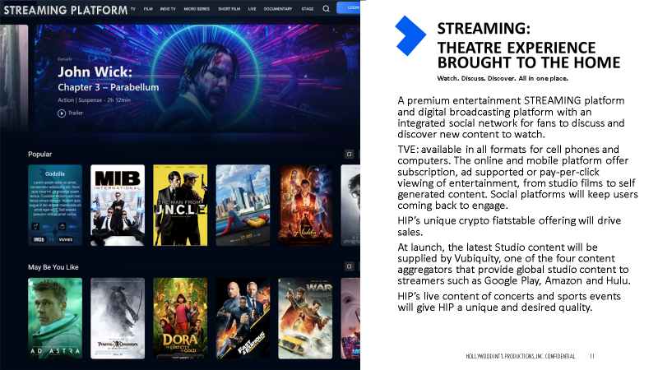 

Management has the expertise to create and organize a state of the art streaming platform, arranging for streaming live video events, and integrating the social media into the viewing experience.

The Management of HIP is briefly described in Attachment D hereto.



The combined expertise of management creates an entertainment and content eco-system that will attract viewers and provide uses for its Token. Management has financed or produced dozens of motion pictures, winning 13 Oscars and 18 Oscar nominations, including winning Oscars for “Best Picture” in consecutive years.



**B. Digital Streaming Platform**

The Company will acquire existing technology to support a state of the art digital platform for the sale and distribution of information and entertainment products to users connected to the Internet or using mobile telephone applications. The HIP digital streaming platform will provide a wide variety of uses for the Token. Tokens may be used to view content, to purchase NFT’s created by the Company or others, to attend concerts, view live sporting events, participate with other users on our platform.



The Company will use its Digital Streaming Platform to publicize and promote its in-house productions. Viewers and subscribers will be enabled to view live content directly from the set of motion pictures in production, to attend press conferences and sporting events, and jump on and view stand-up comedy from around the country. Marketing of the HIP products will include promoting talent and stars, providing a marketing campaign centered around each of them through the creation of NFT’s, fan websites, publicity campaigns, and talent showcases. Stars and talent will have will be made available for live viewing and chat.

Because of the Studio’s extensive line up of motion picture production and content, the Company can award stars with multiple picture contracts and create studio assets, allowing each star to develop their craft and build their brand over the course of their time with Hollywood Int’l Productions.

**IV**

**HIP TOKENS**

The Company is issuing a crypto utility token, denominated as the HIP Token. The purpose for the issuance is to provide a reward in the form of additional income to viewers and subscribers of the Platform, as well as to increase and incentivize viewership. The methodology underlying the HIP Token is a “Rewards and Rebate” program that issues HIP Tokens to viewers based on their viewing habits. In selecting the nature of the HIP Token, it was determined to issue a token that had an intrinsic value in United States Dollars. The HIP Token, as discussed below, is collateralized by a fixed dollar amount held in an account and serves to redeem tokens at the fixed value when requested by the holder. HIP Tokens are redeemable for fiat at the request of the holder of the token. To facilitate using HIP Tokens beyond the HIP eco-system, the Tokens will be listed on multiple exchanges to promote both liquidity and usage.

Because the Tokens will be listed on multiple exchanges, Tokens may be purchased, sold, and traded. As such, the value of the Token may vary due to market pressures, among other factors. The Company may opt to use the market price of the Token to meet its commitments to the Rewards program; nevertheless, the initial fixed price of a Token will always be available to the holder of the Tokens by the Company.

Fiat backed-crypto currency are tokens that are combined with the value of a local fiat currency. Usually, these tokens are based on the US Dollar and hold value fixed at a 1:1 ratio. The most common type of stable-currency is associated or backed, by global currency or fiat currency like USD, EUR, GBP, etc.

Fiat-backed stable-crypto currency are backed at a 1:1 ratio, that means 1 stable-token is equal to 1 unit of currency (such as USD, EUR, or GBP). Although the HIP Tokens have a minimum par value in fiat currency, the value of a token may increase over time due to market forces, scarcity, and increase demand on the platform. The HIP Tokens, are fiat backed with that value held separately in our HIP Token Account.

**FIAT BACKED COINS IN THE MARKET PLACE**

**We have designed our HIP Token, to have several similarities with the prominent stable coins currently in the marketplace as well as a few key differences. Stablecoins** are quickly growing in popularity, with Tether currently at a $78 Billion Market Cap, with a 24 hour trade volume of $60 Billion; USD coin at a market cap of $42 Billion with a 24 hour trade volume of $3 Billion, followed by Binance at $14 Billion, and $4 Billion daily trade volume[1]. Stablecoins, have grown in popularity because they offer individuals the ability to quickly move in and out of both a particular ecosystem as well as the ability to move money quickly.

**Types of Stablecoins:** There are fundamentally three different types ofstablecoins: (a) **Centralized IOU Stablecoins**, such as Trust Token, Gemini, Paxos, (b) **Crypto-Collateralized Stablecoins**; such as Maker Dao, Havven, Sweetbridge; and (c) **Non-Collateralized Stablecoins**, such as Basis, Carbon, Kowala, and Fragments.

**(a) Centralized IOU Stablecoins** are the most straightforward type of stablecoin. Centralized IOU Stablecoins are backed with fiat money or precious metals. Centralized IOU Stablecoins have value because it represents the value of another asset.  Common criticism of this type of stablecoin is its centralized nature, requiring the trust of an issuing party and rather intense regulation. When you deposit fiat into the bank account associated with the stablecoin, the network mints new coins. Conversely, when you go to liquidate Stablecoins, the network burns those coins and you receive the collateral.

The Gemini Dollar (GUSD), launched by Gemini Exchange, and the Paxos Standard Token (PAX), launched by Paxos, are centralized IOU Stablecoins. Both the Gemini Dollar and Paxos Standard Token debuted in early September after approval from the New York Department of Financial Services (NYDFS). Both Stablecoins are ERC-20 tokens collateralized 1:1 with U.S. dollars that are held in US-located and FDIC-insured banks. Gemini and Paxos received BitLicenses in October 2015, and May 2015, respectively.

**(b) Crypto – Collateralized Stablecoins** are backed by digital assets on-chain. This type of stablecoin is collateralized with other crypto assets, such as Ethereum or another token.

(c) **Non-Collateralized Stablecoins:** seniorage shares, a concept invented by Robert Sams in 2014 do not use collateral to support the value of stablecoins.  Seniorage shares use a smart contract to mimic a central bank in which the monetary policy has only one obligation: issue a currency with a value of $1. In other words, the network issues new coins if the price of the stablecoin is too high and burns coins if the price is too low.

**VI**

**HIP Utility Token & Subscriber Rewards Program**

**(a) Earning Rewards: Level 1(G1) and Level 2 (G2) Accounts**

Subscribers/viewers to the Hollywood Int’l Productions Digital Streaming Platform (Platform) will have an opportunity to earn HIP Tokens (Tokens), a crypto currency native to the Platform and the HIP Ecosystem. The Tokens are fiat backed utility tokens, with the value for each token held in a separately managed account. Each Subscriber will earn tokens, for watching advertising supported content on the Platform.

**What sets HIP apart from all of the other Streaming Platforms (like Netflix, Hulu, Roku, Peacock, etc.) is that HIP Subscribers/viewers are rewarded for watching content on our Platform and for referring others to participate in the HIP OTT platform.**

Hollywood Int’l Productions, Inc. (Company) earns revenues by selling advertising time slots in our programs to companies that want to reach the public. The Company rewards its Subscriber/viewers by sharing a portion of the Advertising revenue the Company earns with each Subscriber who watches ad supported content on our Platform. Other rewards programs based upon other resources within the Company may be implemented by Management.

The HIP Rewards Program works by segmenting the 24 hour day into ten minute blocks of time, creating 144 ten minute blocks per day. As a Subscriber/viewer watches a 30 minute program on our Platform, our proprietary algorithms will attribute three 10 minute blocks of the 144 blocks for that day to that Subscriber’s account. The algorithm will credit the correct number of HIP tokens to that account and direct the accounting block chain to pay that amount to the Subscriber’s private account initially maintained in wallets on the Company’s site. For every 10 minutes that Subscribers watch ad supported content on the Platform, they will earn a specific number of HIP Tokens.

2nd Generation accounts are those accounts that a Subscriber has introduced to our streaming Platform on a referral basis. As part of the subscription process, each Subscriber will be asked for permission to use their mailing list and friends lists so that the Company can solicit new accounts. The initial Subscribers (G1) and the referred Subscribers (G2) both earn rewards: the Company will pay rewards for each account that signs up under a customer specific referral code The Company will pay rewards to the original account Subscriber (G1) for viewed ad supported content, plus an additional amount based upon the viewing of his/her G2 (Referred) Subscribers. Each G2 Subscriber becomes its own G1 Subscriber to his/her G2 Subscribers. The number of G2 Subscribers is unlimited. Our algorithms track all such relations and direct payments through a block chain smart contract. The family of algorithms used by the Company tracks the dispersal of the Tokens to the appropriate account and receives feedback when that account is accessed.

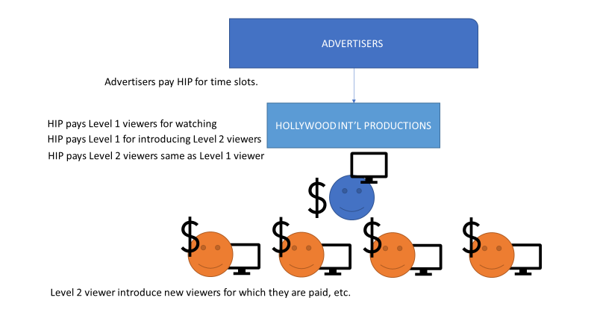

**(b) HIP Token**

The HIP Token is a utility token that may be used to access additional services on the HIP platform, as well as the primary means for HIP to distribute the rewards earned on the HIP OTT Platform. Other uses for HIP Tokens include payment for content and affiliate offerings available through or by the Platform, including pay per view content, online streaming content, live concerts and sporting events, and many others.

The Company will mint 10,000,000,000 (ten billion) tokens. Each HIP token will have a minimum par value of $0.10 (USD).

The process that will ensure that HIP tokens to maintain a $0.10 par value, is built into the algorithms that require a deposit of $0.10 into a managed account for every token activated or gemstone collateral in the same amount. Tokens can only come into existence after they are earned on our network and the appropriate amount contributed to the designated fiat account supporting the valuation. Initially, the Company’s gemstones have a value of $50Million against which the Company will initially issue 250 million tokens, leaving an unused balance equal to roughly half the value of the gemstones.

The Platform will earn revenue from our advertising sponsors for every minute a Subscriber watches. An amount equal to the amount of rewards earned by our Subscribers/viewers (and equal to the number of HIP Tokens, that we will be activating) will be transferred into a separate actively managed account. This separate actively managed account stores $0.10 in real US dollars for every HIP Token that becomes active and is distributed as a reward on our Platform.

As each Subscriber’s monthly rewards is calculated, the corresponding dollar value for each activated Token that is activated transferred from to the Company’s HIP Managed Account. The Company will hire an independent CPA firm to verify the underlying value of the assets under management and will redeem for dollars or collateral any Tokens owned by Subscribers. All redemptions will be at the par value of $0.10 per Token, while any and all redemptions on a partnered exchange will be traded at current market value.

**(c) Exchanges and Secondary Markets for HIP Tokens**

The Company will be seed to work with crypto exchanges and selected banks to enable and facilitate the usage of the Tokens, such as Binance, Coinbase, FTX, Kraken, Crypto Exchange, Bitpay, Rhino Exchange, AoneX, to name a few.

**Glossary**

Digital currency: As defined by <http://en.wikipedia.org/wiki/Digital_currency>

Cryptocurrency or decentralized digital currency: any type of cryptocurrency that is open­source, cryptographically secure, and uses a distributed ledger. See: <http://en.wikipedia.org/wiki/Cryptocurrency>

Real­world currency, or fiat currency, or national/sovereign currency: all types of currency that are not cryptocurrencies as defined above.

Cryptocurrency system: A collection of software and processes primarily created to enable the existence of a cryptocurrency.

Legacy financial system: any financial system that is not a cryptocurrency system.

Utility ­backed digital tokens: A digital token whose value is derived from the usefulness of its application.

Par Value, Par value, in finance and accounting, means stated value or face value. From this come the expressions at par (at the par value), over par (over par value) and under par (under par value). In HIP, the par value is $0.10 per Token, equal to the amount stored at the token’s activation and issuance.

Asset­backed/pegged cryptocurrency: Any cryptocurrency whose price is pegged to a real­world asset, i.e. it’s not a “utility­backed” cryptocurrency.

HIP Token (Token): a single unit (or multiple units) of fiat backed cryptocurrency issued by HIP.

HIP Eco-system: the affiliated businesses of HIP, including all processes and technologies that enable the issuance, management, storage, redemption, and auditing of the Token.

Proof of Reserves: The process by which HIP cryptographically/mathematically proves that all Tokens that have been issued are fully reserved and backed by the underlying asset.

1. Information provided by Stablecoinswar.com on December 29, 2021